Project Report: Handheld Multi-Sensory Currency Detector

1. Introduction
The objective of this project is to design and develop a portable, handheld device capable of identifying currency & its value. This device is specifically engineered to assist the visually impaired and commercial handlers by providing both visual and auditory feedback.

2. System Architecture & Components
The device follows a modular design to ensure portability and efficiency. The integration of image processing with audio synthesis allows for a "multi-sensory" user experience.

A. Image Acquisition (The Camera)
- Component: CMOS Camera Module (e.g.,ESP32-CAM).
- Role: The camera acts as the primary sensor. It captures a frame of the banknote.

B. Central Processing (The Microcontroller)
- Component: High-speed Microcontroller (e.g.,ESP32).
- Role: The "brain" of the device. It performs the following tasks:
  - Image Pre-processing: Converts images to grayscale and resizes them.
  - Pattern Matching: Compares the captured data against stored templates or a lightweight Neural Network.
  - Instruction Routing: Sends the result to both the display and the audio module simultaneously.

C. Visual Feedback (The LCD)
- Component: TFT LCD Display.
- Role: Provides a clear visual readout of the currency value (e.g., "$50 USD") and the system status (e.g., "Scanning")
- Design: High-contrast text is used to ensure readability for users with low vision.

D. Auditory Feedback (MP3 Module & Speaker)
- Components: DFPlayer Mini (MP3 Module) + 8-ohm Micro Speaker.
- Role: To make the device accessible, an MP3 module stores pre-recorded voice clips for each denomination.

3. Power Management & Portability
To ensure the device is truly handheld and practical for daily use, a robust power circuit is integrated:
- Energy Source: A Lithium-Ion (Li-ion) Battery (e.g., 18650 or Li-Po) provides the high current required for image processing.
- Charging System: A TP4056 Charger Module with a USB-C or Micro-USB port allows the user to recharge the device using standard mobile chargers.
- User Control: A physical Toggle Switch or momentary push-button manages the power state, preventing parasitic battery drain when the device is in a pocket or bag.
Item No. | Item | Price  in EGP | Seller
1 | ESP32 Camera | 510 | Free Electronics
2 | Perfboard | 25 | Free Electronics
3 | Solder wire | 120 | Free Electronics
4 | IPS Screen 240x240 1.3 inch | 300 | Free Electronics
5 | Switch | 2.5 | Free Electronics
6 | Battery | 120 | Free Electronics
7 | Battery charger TP4056 | 30 | Free Electronics
9 | MP3 TP16 Module | 120 | Free Electronics
10 | Speaker 8 ohm | 12 | Free Electronics
11 | Wires & Headers | 50 | Free Electronics

Description of each component:

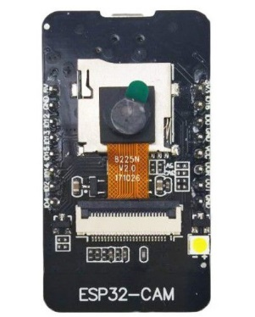
1- ESP32 Camera:
It is an esp32 which is a very famous microcontroller with Wi-Fi and Bluetooth capability also with high clock frequency which is used in processing paired with a camera module used in computer vision applications.
Its main role here is to capture and process images also to broadcast visuals to the LCD and speech to the mp3 module.
2- Perfboard:
It is a breadboard alternative but used for more permanent connection by means of soldering.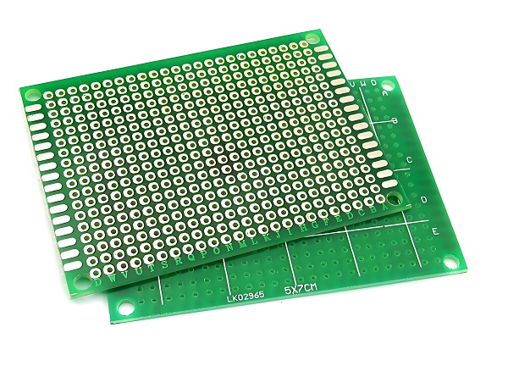
3- Solder wire:
It is used to bond wires with the perfboard.
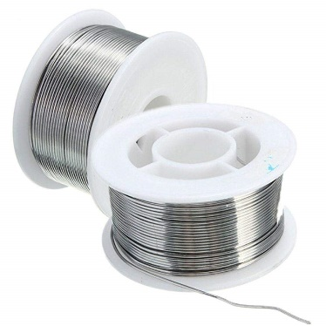

4- IPS Screen 240x240 1.3 inch:
It is used for visuals in this project paired with a microcontroller to handle the graphics and it communicates with the esp32 by means of SPI.
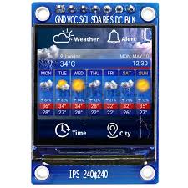
5- Switch:
It is used to complete the circuit upon switching on.
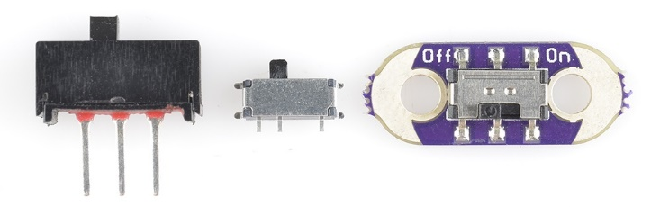
6- Battery:
it is used as a power source.
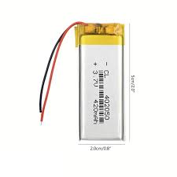

7- Battery charger TP4056:
Used for charging the battery.
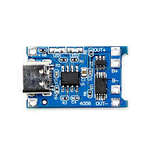
8- MP3 TP16 Module:
It is used for speaker output to read the currency detection output.
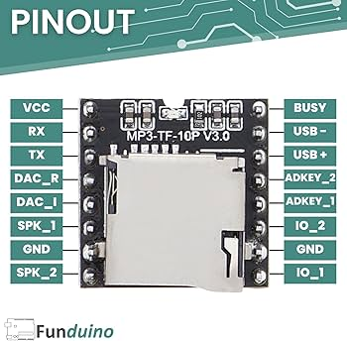
9- Speaker 8 ohm:
Used to output sound.

10- Wires & Headers:
Used for connection between components.
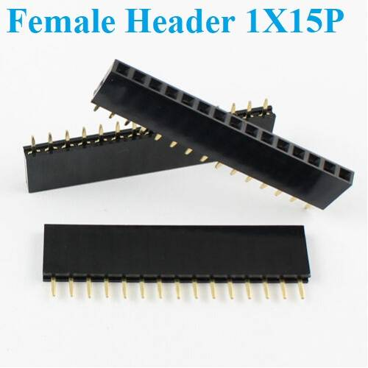
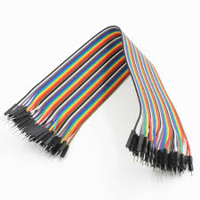

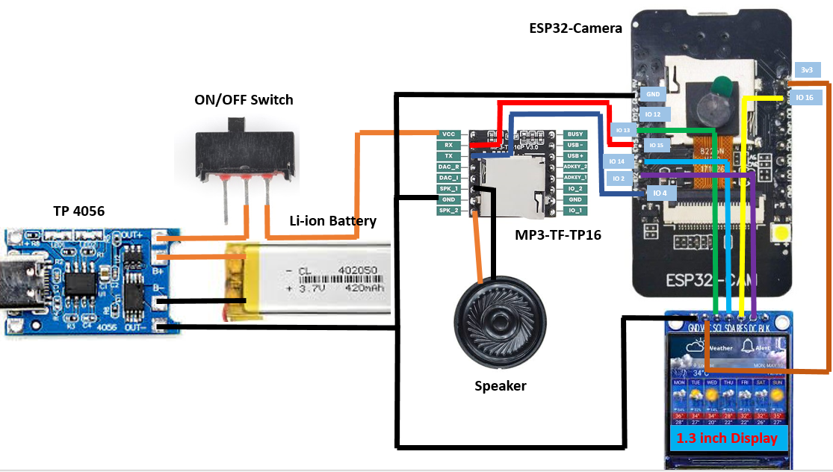
Wiring Diagram:

